





Auction Location

Spink County Fairgrounds Building Redfield, SD



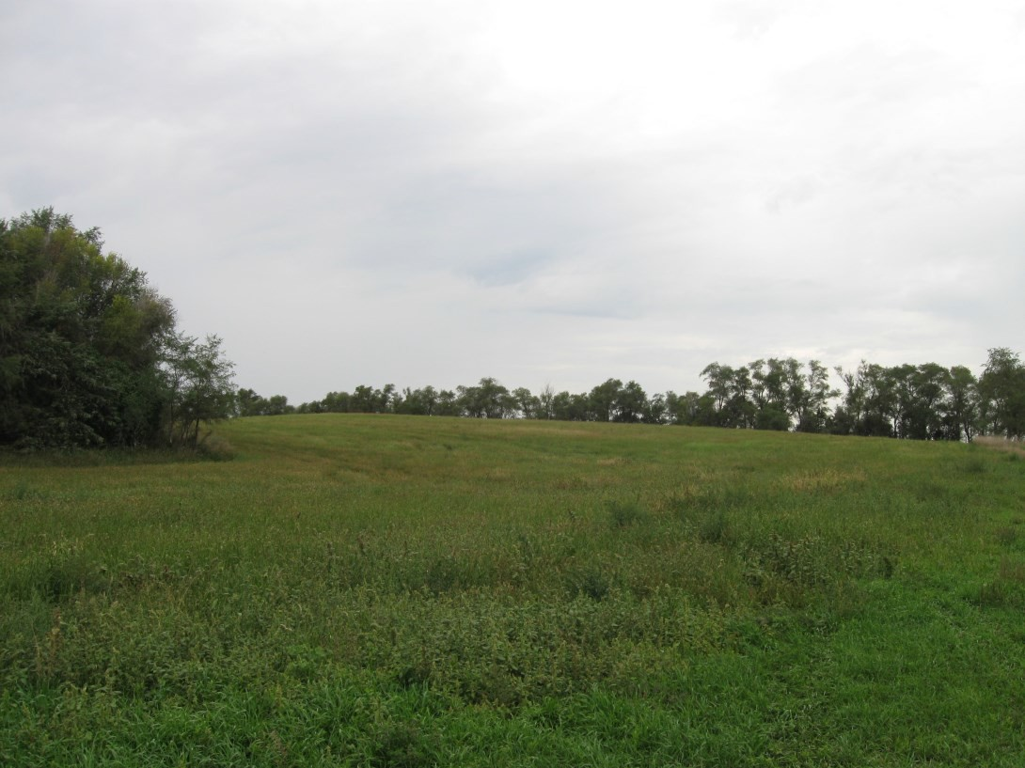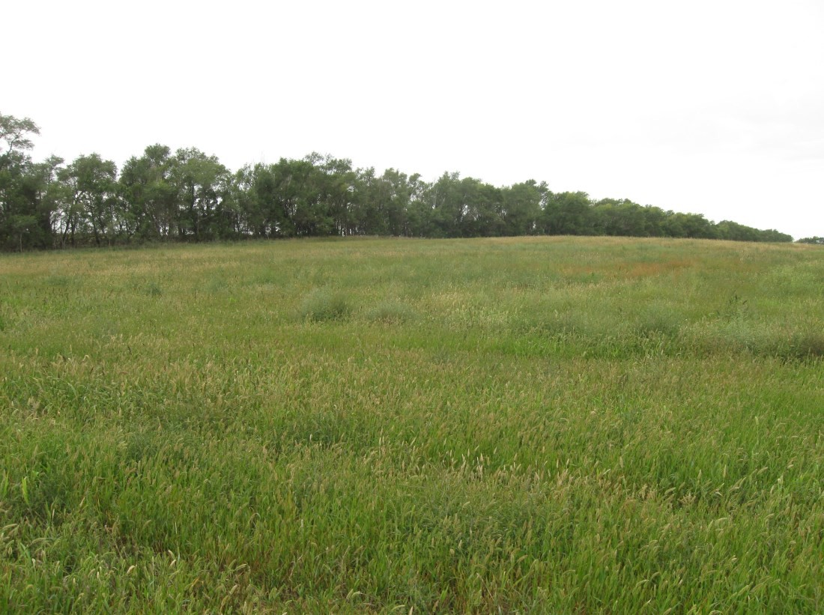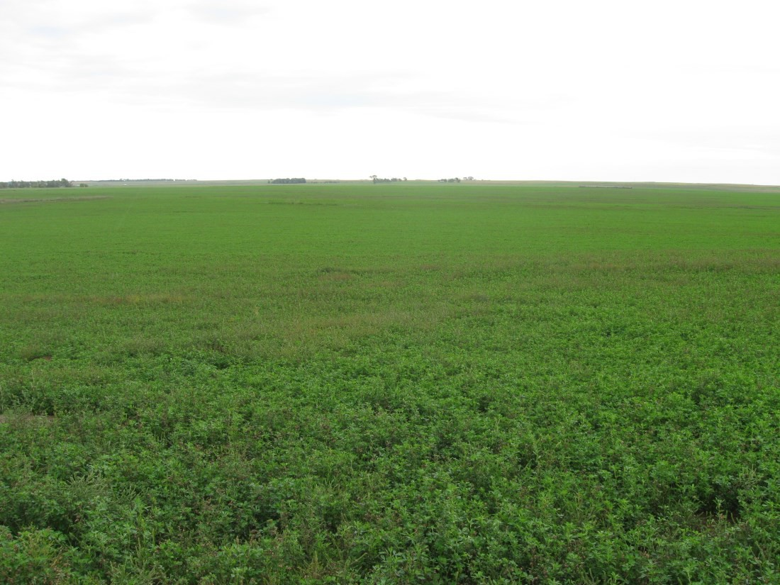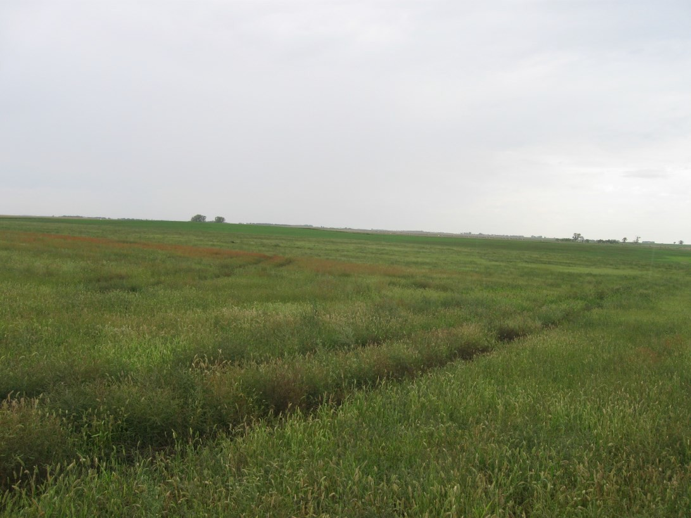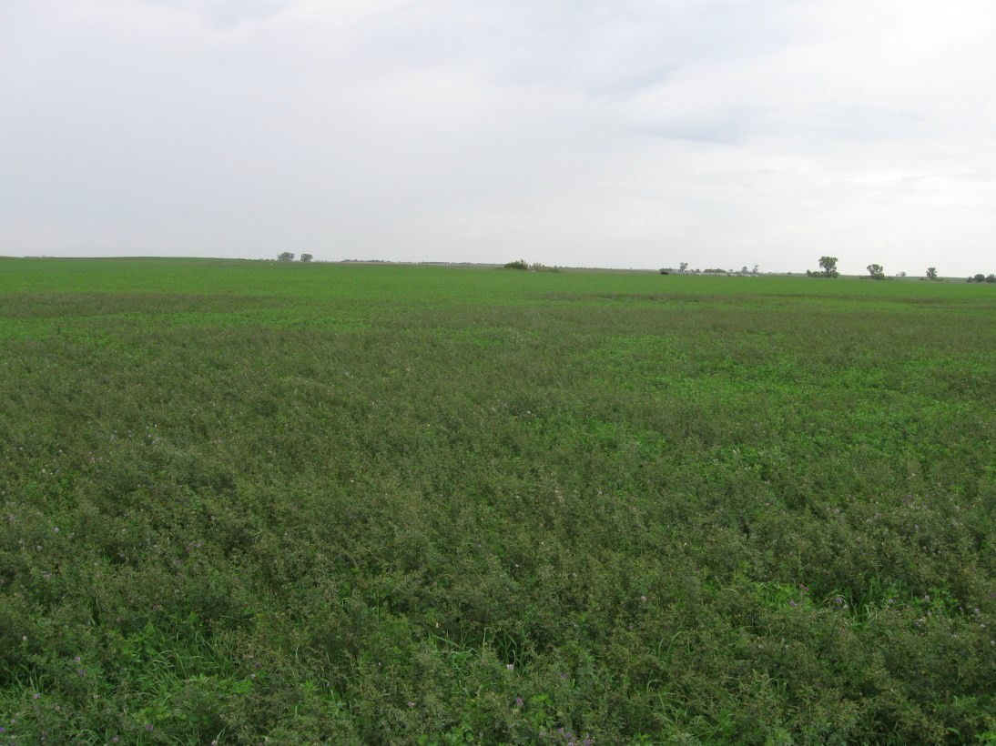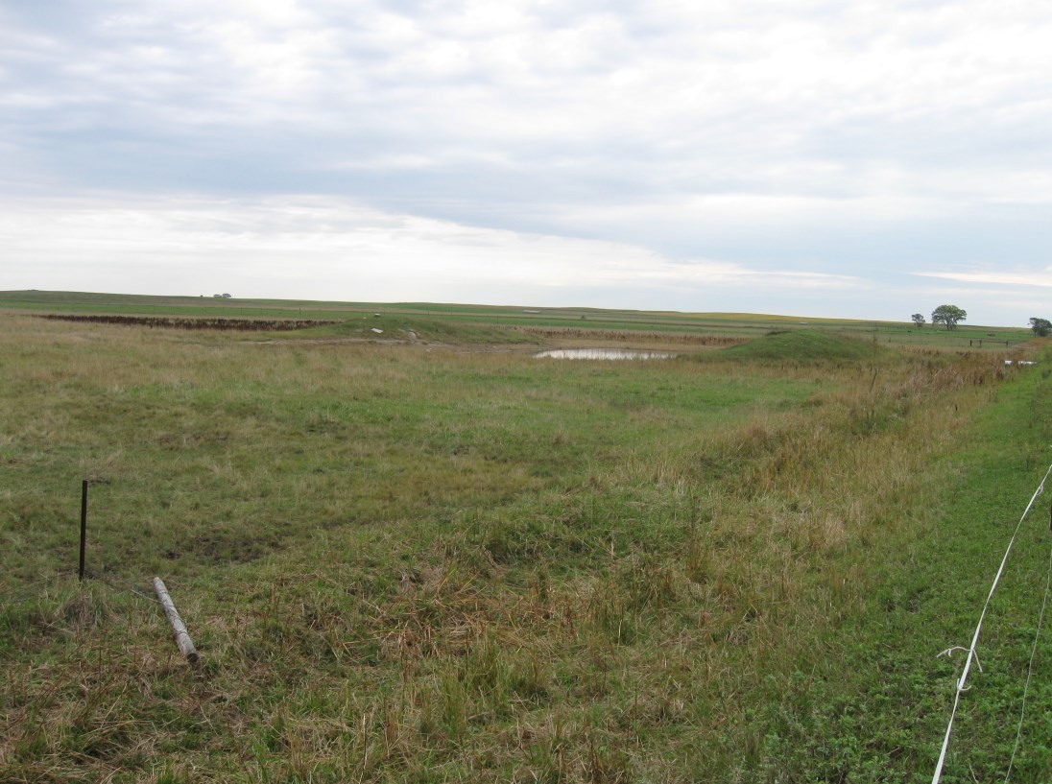

# Welcome

We would like to invite and welcome you to our public auction! This is a great opportunity to add Spink County Cropland to your portfolio. This Zell, SD area land offers farming, grazing, hunting & investment opportunities!

# Legal Descriptions

**Lot 1 - SE ¼ of 5-116-65**

**Exline Township, Spink County, SD**

**Lot 2 - SW ¼ of 4-116-65**

**Exline Township, Spink County, SD**

* **It is our intention to offer choice of Lots 1 & 2. High bid may take Lot 1 ($ x 160 taxable acres), Lot 2 ($ x 160 taxable acres) or Lots 1 & 2 combined ($ x 320 taxable acres). If high bid only takes one tract, we will then offer the remaining Lot.**

**--------------------**

* + **Buyer(s) will have the right to operate in 2022!**

**--------------------**

# Disclaimer

While we feel that all information is correct, it is your responsibility as buyers to research any/all information to your own satisfaction.

Terms

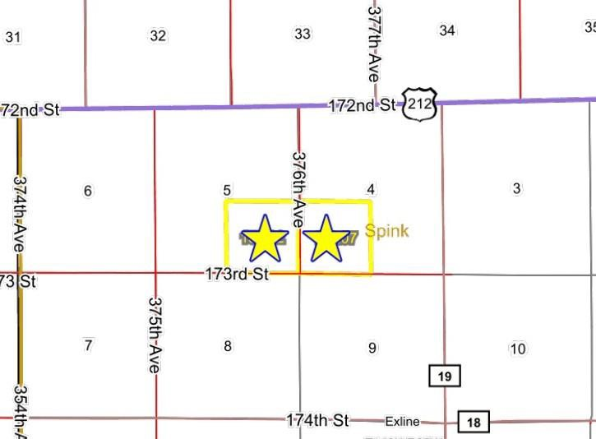**TERMS**

Successful bidder(s) will deposit 10% down as irrevocable earnest money on day of sale. The balance will be due at closing which will be within 30 days of date of sale. The cost of title insurance and closing service fees will be divided equally between buyer and seller. The Closing Agent is Paul Gillette, Gillette Law Office, Redfield, SD. Jark/Worlie Auction, LLC & Paul Gillette are acting as agent for sellers.

Possession will be given December 31, 2021. The 2021 real estate taxes (due in 2022) will be paid by seller. Seller will convey to buyer any gas, oil, mineral or hunting rights now owned. Seller reserves the right to accept or reject any or all bids. Announcements made the day of sale shall take precedence over written advertisements. These parcels are offered subject to any rights, easements, restrictions and/or reservations of record. No buyer contingencies of any kind – have financial arrangements secured prior to bidding.

SE ¼ of 5-116-65

Exline Township, Spink County, SD

This tract is offered $ x 160 taxable acres.

**FSA has tract as 158.27 Farmland Acres of which 139.67 are considered Cropland. The balance will be pasture, shelter belts, non-crop acres, and right of ways. * Tract contains an *FSA wetland or farmed wetland. * No USFWS Easements \****

## ** Buyers will have the right to operate in 2022! **

### COUNTY PARCEL RATINGS:

.664

SURETY PRODUCTIVITY INDEX: 68.8 SURETY RANGE PRODUCTION: 3085.1 (lbs./acre/yr.)

### BASE ACRES:

Wheat 32.5, Corn 19.4, Soybeans 44.0, Barley 6.2 Total Base Acres: 102.1

### 2020 REAL ESTATE TAXES:

$2,807.18

**LOCATION**

From Zell, SD go - 2 miles East on Hwy 212, 1 mile South (375 Ave) & ½ mile East (173 St.).

**2**

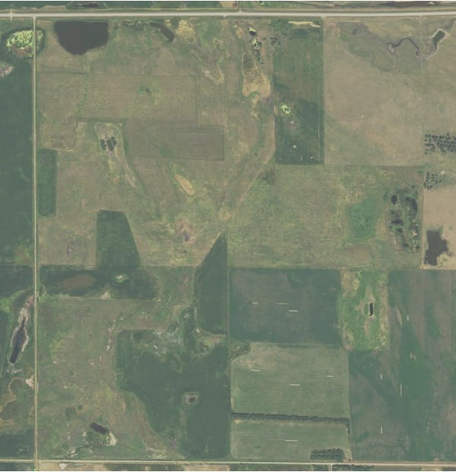

**14.89**

**1**

**139.67**

**NHEL**

**4**

²

**1.34**

0

330

660 1,320

Feet

**Common Land Unit**

Non-Cropland Cropland

**Wetland Determination**

&- Restricted Use Limited Restrictions

■) Exempt from Conservation Compliance Provisions

Tract Boundary PLSS

2021 Program Year

Map Created May 06, 2021

**5-116N-65W-Spink**

United States Department of Agriculture (USDA) Farm Service Agency (FSA) maps are for FSA Program administration only. This map does not represent a legal survey or reflect actual ownership; rather it depicts the information provided directly from the producer and/or National Agricultural Imagery Program (NAIP) imagery. The producer accepts the data 'as is' and assum es all risks associated with its use. USDA-FSA assumes no responsibility for actual or consequential damage incurred as a result of any user's reliance on this data outside FSA Program s. Wetland identifiers do not represent the size, shape, or specific determination of the area. Refer to your original determination (CPA-026 and attached maps) for exact boundaries and determinations or contact USDA Natural Resources Conservation Service (NRCS).

SW ¼ of 4-116-65

Exline Township, Spink County, SD

This tract is offered $ x 160 taxable acres.

**FSA has tract as 156.8 Farmland Acres of which 119.34 are considered Cropland. The balance will be pasture w/dugout, non-crop acres, and right of ways. * Tract contains an *FSA wetland or farmed wetland. * No USFWS Easements \****

## ** Buyers will have the right to operate in 2022! **

### COUNTY PARCEL RATINGS:

.460

### SURETY PRODUCTIVITY INDEX: 53.0

SURETY RANGE PRODUCTION: 2872.3 (lbs./acre/yr.)

### BASE ACRES:

Wheat 29.50, Corn 17.6, Soybeans 31.8, Barley 5.6 Total Base Acres: 84.50

### 2020 REAL ESTATE TAXES:

$1,939.76

**LOCATION**

From Zell, SD go - 2 miles East on Hwy 212, 1 mile South (375 Ave) & 1 mile East (173 St.).

-&

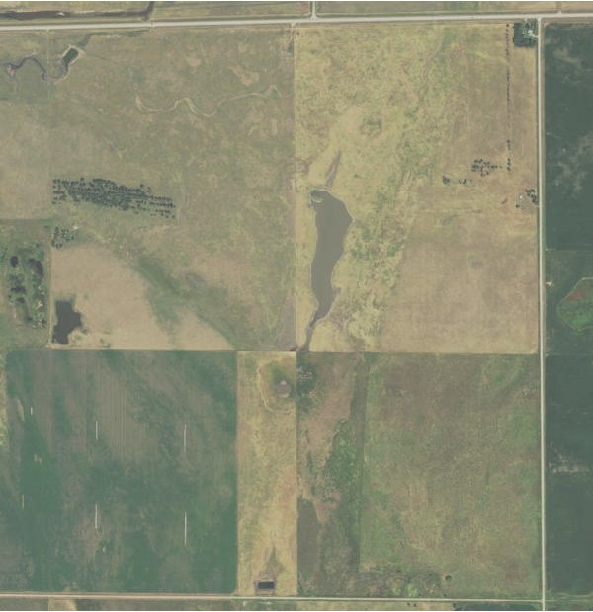

**1 37.46**

**2**

²

**119.34**

**NHEL**

0 340

680 1,360

Feet

**Common Land Unit**

Non-Cropland Cropland

**Wetland Determination**

&- Restricted Use Limited Restrictions

■) Exempt from Conservation Compliance Provisions

Tract Boundary PLSS

2021 Program Year

Map Created May 06, 2021

**4-116N-65W-Spink**

United States Department of Agriculture (USDA) Farm Service Agency (FSA) maps are for FSA Program administration only. This map does not represent a legal survey or reflect actual ownership; rather it depicts the information provided directly from the producer and/or National Agricultural Imagery Program (NAIP) imagery. The producer accepts the data 'as is' and assum es all risks associated with its use. USDA-FSA assumes no responsibility for actual or consequential damage incurred as a result of any user's reliance on this data outside FSA Program s. Wetland identifiers do not represent the size, shape, or specific determination of the area. Refer to your original determination (CPA-026 and attached maps) for exact boundaries and determinations or contact USDA Natural Resources Conservation Service (NRCS).

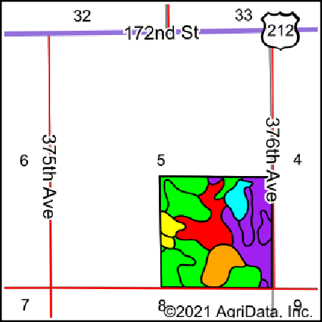

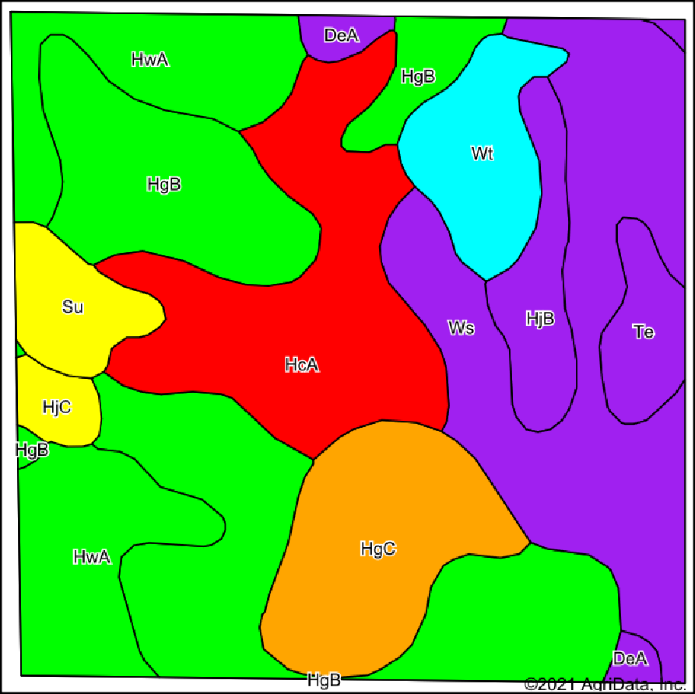State: **South Dakota**

County: Location:

**Spink**

**5-116N-65W**

Soils data provided by USDA and NRCS.

Township: **Exline**

Acres: **158.43**

Date: **2/1/2021**

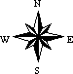

|  |  |  |  |  |  |  |  |  |
| --- | --- | --- | --- | --- | --- | --- | --- | --- |
|  | | | | | | | | |
| Code | Soil Description | Acres | Percent of field | PI  Legend | Non­Irr Class *c | Range Production (lbs/acre/yr) | Productivity Index | *n NCCPI  Soybeans |
| HgB | Hand­Ethan­Bonilla loams, 1 to 6 percent slopes | 40.88 | 25.8% |  | IIe | 2958 | 79 | 55 |
| Ws | Woonsocket­Whitelake fine sandy loams, 0 to 2 percent slopes | 30.03 | 19.0% |  | IIIe | 2526 | 59 | 41 |
| HcA | Hand­Bonilla loams, 0 to 3 percent slopes | 23.28 | 14.7% |  | IIc | 3206 | 88 | 57 |
| HwA | Houdek­Stickney complex, 0 to 2 percent slopes | 20.97 | 13.2% |  | IIc | 3141 | 77 | 59 |
| HgC | Hand­Ethan­Bonilla loams, 2 to 9 percent slopes | 15.10 | 9.5% |  | IIIe | 2738 | 65 | 54 |
| Wt | Worthing silty clay loam, 0 to 1 percent slopes | 8.34 | 5.3% |  | Vw | 6145 | 30 | 4 |
| HjB | Hand­Talmo complex, 2 to 6 percent slopes | 6.13 | 3.9% |  | IIe | 2336 | 54 | 39 |
| Su | Stickney­Dudley­Hoven silt loams, 0 to 2 percent slopes | 5.07 | 3.2% |  | IIIs | 2859 | 44 | 37 |
| Te | Tetonka silt loam, 0 to 1 percent slopes | 4.39 | 2.8% |  | IVw | 4479 | 56 | 14 |
| DeA | Delmont­Enet loams, 0 to 2 percent slopes | 2.16 | 1.4% |  | IVs | 2606 | 50 | 39 |
| HjC | Hand­Talmo complex, 6 to 9 percent slopes | 2.08 | 1.3% |  | IIIe | 2306 | 44 | 38 |
| **Weighted Average** | | | | | | **3085.1** | **68.8** | **\*n 47.6** |

*n: The aggregation method is "Weighted Average using all components"

*c: Using Capabilities Class Dominant Condition Aggregation Method Soils data provided by USDA and NRCS.

**LOT 1**

Low

Elevation

High

Source: Interval(ft):

Min:

Max:

USGS 3 meter dem 3

1,314.2

1,367.2

0ft 432ft 865ft

**5-116N-65W**

Range: 53.0

Average: 1,330.2

2/1/2021

**Spink County South Dakota**

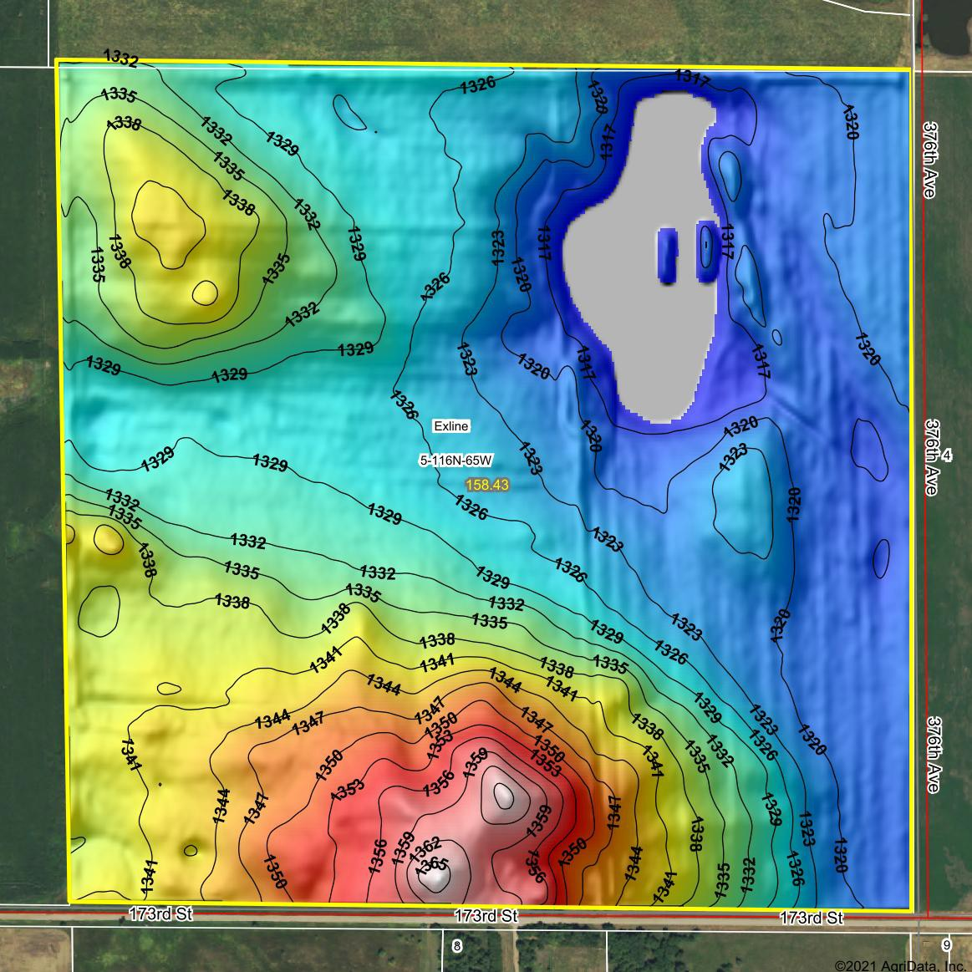

Field borders provided by Farm Service Agency as of 5/21/2008.

Standard Deviation:

11.45 ft

map center:44° 53' 19.47, -98° 40' 34.79

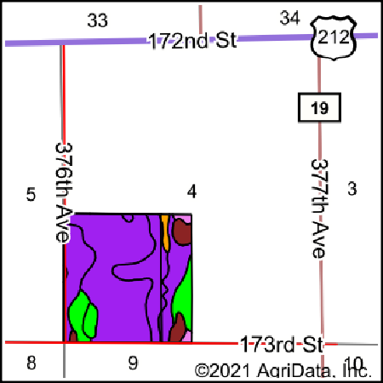

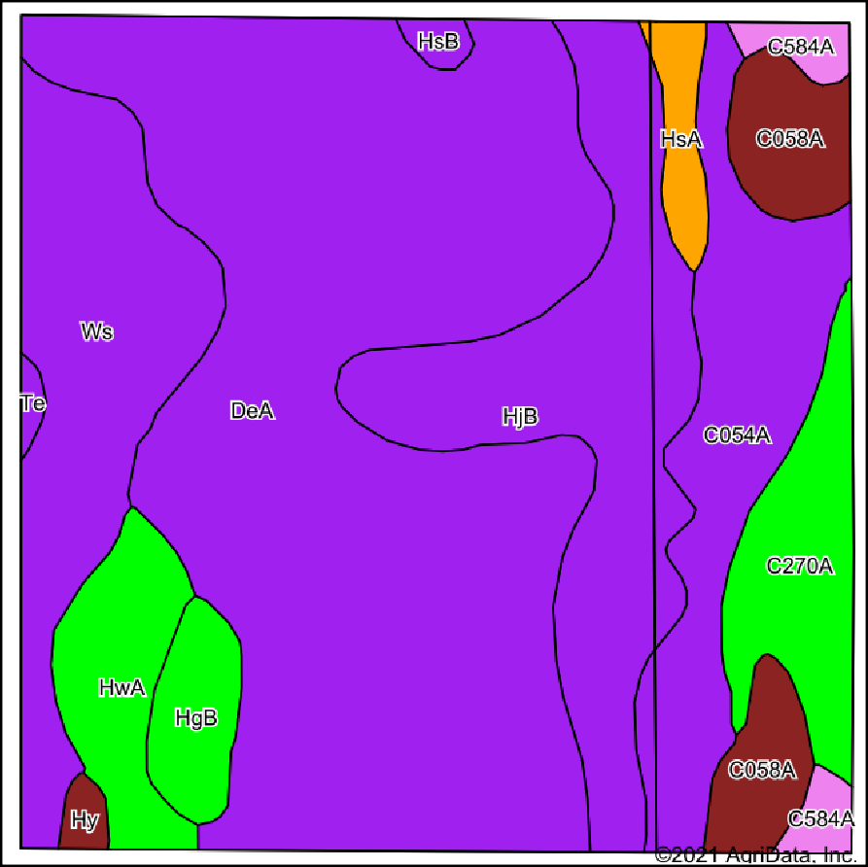State: **South Dakota**

County: Location:

**Spink**

**4-116N-65W**

Soils data provided by USDA and NRCS.

Township: **Exline**

Acres: **156.8**

Date: **2/1/2021**



|  |  |  |  |  |  |  |  |  |
| --- | --- | --- | --- | --- | --- | --- | --- | --- |
|  | | | | | | | | |
| Code | Soil Description | Acres | Percent of field | PI  Legend | Non­Irr Class *c | Range Production (lbs/acre/yr) | Productivity Index | *n NCCPI  Soybeans |
| DeA | Delmont­Enet loams, 0 to 2 percent slopes | 69.94 | 44.6% |  | IVs | 2606 | 50 | 39 |
| HjB | Hand­Talmo complex, 2 to 6 percent slopes | 22.30 | 14.2% |  | IIe | 2336 | 54 | 39 |
| Ws | Woonsocket­Whitelake fine sandy loams, 0 to 2 percent slopes | 17.84 | 11.4% |  | IIIe | 2526 | 59 | 41 |
| C054A | Lowe loam, 0 to 2 percent slopes, occasionally flooded | 15.26 | 9.7% |  | IVw | 4322 | 53 | 26 |
| C270A | Hamerly loam, 0 to 3 percent slopes | 8.15 | 5.2% |  | IIe | 3721 | 76 | 47 |
| C058A | Ludden silty clay loam, strongly saline, 0 to 1 percent slopes, occasionally flooded | 7.01 | 4.5% |  | IIw | 3380 | 11 | 17 |
| HwA | Houdek­Stickney complex, 0 to 2 percent slopes | 6.59 | 4.2% |  | IIc | 3141 | 77 | 59 |
| HgB | Hand­Ethan­Bonilla loams, 1 to 6 percent slopes | 3.61 | 2.3% |  | IIe | 2958 | 79 | 55 |
| HsA | Henkin­Blendon fine sandy loams, 0 to 2 percent slopes | 2.25 | 1.4% |  | IIIe | 2814 | 62 | 44 |
| C584A | Harriet loam, 0 to 2 percent slopes | 2.14 | 1.4% |  | VIs | 3405 | 26 | 16 |
| Hy | Hoven silt loam, 0 to 1 percent slopes | 0.67 | 0.4% |  | VIs | 3600 | 15 | 5 |
| HsB | Henkin­Blendon fine sandy loams, 2 to 6 percent slopes | 0.65 | 0.4% |  | IIIe | 2814 | 57 | 43 |
| Te | Tetonka silt loam, 0 to 1 percent slopes | 0.39 | 0.2% |  | IVw | 4479 | 56 | 14 |
| **Weighted Average** | | | | | | **2872.3** | **53** | **\*n 38.2** |

*n: The aggregation method is "Weighted Average using all components"

*c: Using Capabilities Class Dominant Condition Aggregation Method Soils data provided by USDA and NRCS.

**LOT 2**

Low

Elevation

High

Source: Interval(ft):

Min:

Max:

USGS 3 meter dem 3

1,308.5

1,325.4

0ft 431ft 862ft

**4-116N-65W**

Range: 16.9

Average: 1,318.5

2/1/2021

**Spink County South Dakota**

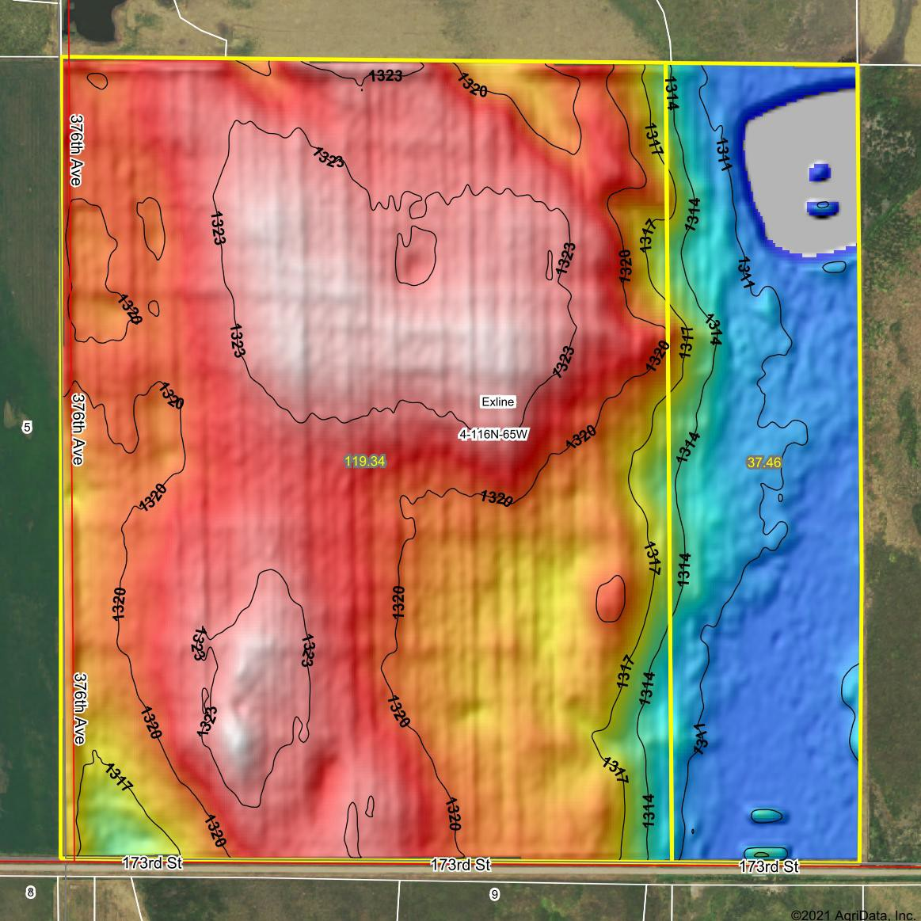

Field borders provided by Farm Service Agency as of 5/21/2008.

Standard Deviation:

4.79 ft

map center:44° 53' 19.77, -98° 39' 22.02